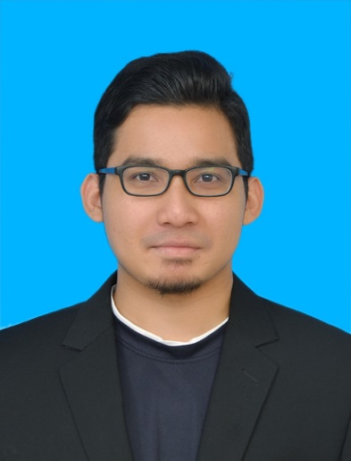**MUHAMMAD ANAS BIN MOHD AZAM**

Communication Engineering

[anasazam1994@gmail.com](mailto:anasazam1994@gmail.com)

**Expected graduation date: FEBRUARY 2018**

|  |  |  |  |  |
| --- | --- | --- | --- | --- |
| **PERSONAL INFORMATION** | | | | |
| **Name** | MUHAMMAD ANAS BIN MOHD AZAM | | | |
| **IC Number** | 940502-07-5513 | | **Date Of Birth** | 2 MAY 1994 |
| **Nationality** | MALAYSIAN | | **Marital Status** | SINGLE |
| **Gender** | MALE | | **Phone Number** | 019-4555346 |
| **Age** | 23 | | **Religion** | ISLAM |
| **Permanent Address** | NO 333, BATU 6, KG TERSUSUN KELEBANG SELATAN, 31200, IPOH, PERAK DARUL RIDZUAN | | | |
|  | | | |
|  | | | |
| **EDUCATION BACKGROUND** | | | | |
| **INTERNATIONAL ISLAMIC UNIVERSITY MALAYSIA (2016-CURRENT)** | | | | |
| **Education Level** | | Bachelor in Communication Engineering (Hons) | | |
| **Major** | | Communication Engineering | | |
| **Faculty** | | Kulliyyah of Engineering | | |
| **Current CGPA** | | 2.515 | | |
| **CENTRE FOR FOUNDATION STUDIES**  **INTERNATIONAL ISLAMIC UNIVERSITY MALAYSIA (2013-2014)** | | | | |
| **Education Level** | | Foundation in Engineering and Computer Science | | |
| **CGPA** | | 2.501 | | |
| **SEKOLAH MENENGAH KEBANGSAAN AGAMA SULTAN AZLAN SHAH (2010-2011)** | | | | |
| **Education Level** | | SIJIL PELAJARAN MALAYSIA (SPM) | | |
| **GRED** | | 6A4B1C | | |
| **SEKOLAH MENENGAH KEBANGSAAN AGAMA SULTAN AZLAN SHAH(2007-2009)** | | | | |
| **Education Level** | | PENILAIAN MENENGAH RENDAH (PMR) | | |
| **GRED** | | 7A2B | | |
| **SEKOLAH KEBANGSAAN SERI BAYU (2001-2006)** | | | | |
| **Education Level** | | UJIAN PENILAIAN SEKOLAH RENDAH (UPSR) | | |
| **GRED** | | 5A | | |

|  |
| --- |
| **OBJECTIVE** |
| * To find and learn from experience of being able to work at great company * To have a stable and challenging career that used my personal capability and creativity where I can enhance my skills and improve my knowledge |
| **STRENGTH** |
| * Good communication skills * Positive Attitude * Self-Motivated * Fast learner * Able to work independently and in a team, under pressure and without supervision * Good at being punctual |

|  |  |  |
| --- | --- | --- |
| CO-CURRICULUM PARTICIPATIONS | | |
| **POSITIONS** | **EVENTS/CLUBS** | **YEAR** |
| Participant | Annual General Meeting ( STUFF) | 2014/2015 |
| Participant | Career Programme | 2015/2016 |
| Participant | Entrepreneurship Culturisation | 2015/2016 |
| Committee | Family Day and Facilitating Skill\Training Program (FAMSTRAP) | 2015/2016 |
| Participant | Family Day and Facilitating Skill\Training Program (FAMSTRAP) | 2015/2016 |
| Participant | Gathering For New Members & STUFF Ukhuwah Induction Training | 2015/2016 |
| Participant | Grooming For Facilitators | 2015/2016 |
| Main Committee | Kem Kepimpinan Genius Leader | 2015/2016 |
| Main Committee | Mass Gathering For New Members | 2015/2016 |
| Committee | Mass Gathering STUFF For New Members | 2015/2016 |
| Participant | Otai Training | 2015/2016 |
| Participant | STUFF Appreciation Night | 2015/2016 |
| Main Committee | STUFF Festival 2.0 | 2015/2016 |
| Participant | STUFF Training | 2015/2016 |
| Program Coordinator | STUFF Training | 2015/2016 |
| Participant | Wacana Ilmiah Sahabat Yadim | 2014/2016 |

# are judge based on Beginner, Intermediate, Good and Advance

#rank according to 0 being the lowest and 10 being the highest

|  |  |  |  |  |
| --- | --- | --- | --- | --- |
| **SKILLS AND LANGUAGE** | | | | |
| **LANGUAGE PROFICIENCY\*** | | | **COMPUTER RELATED SKILLS\*** | |
| **ENGLISH LANGUAGE** | SPEAKING | 10 | C Programming Language (Dev C++) | Good |
| WRITING | 10 | Microsoft Office | Good |
| READING | 9 | SolidWorks | Good |
| **MALAY LANGUAGE** | SPEAKING | 10 | PSPICE | Good |
|  |  |  |  |
| WRITING | 10 | Adobe ( Photoshop, Illustrator, After Effect, Flash) | Good |
| READING | 9 | MATLAB | Good |
|  |  | Arduino Computer Knowledge | Good |
| **SOFT SKILLS\*** | | | | |
| **Leadership & Management Skills** | | | | 10 |
| **Presentation Skills** | | | | 10 |

Remarks

Work Experience:

1. Semester break Part-Time jobs at Powerix Station SDN BHD as a salesman and also a technician. Reference No: 012-3220062 (Ms. Shirley)
2. Business in the event occur in IIUM, Manager and also salesman.

Reference No: 018-2943347 (Syahidah)